MopedRebelGO
Game Design Document

Lede

A rebel in the land of conformist moped users, moped rebel (MR) is a too-cool-for-school punk that doesn't abide by the rules and is always out looking for ways to undermine the “Man”, man…
Sadly, MR has to balance this hobby with their very mundane delivery service job, working moped deliveries for CargoRiders™ . Armed with nothing but a moped and a bad attitude, MR are out for blood on the bloodless streets of Nothingtown, TheCountry. Their goal? To somehow make enough of a living with enough street cred in this dingy town to leave the deadbeat job of delivery moped for a lucrative career of their own choice.

Gameplay

Delievery (Stage)
Every delivery is a fixed number of fixed length tracks running in parallel (like audiosurf but scrolling sideways, not forward)
Some of these tracks are non-regulation for fast mopeds (marked green?) while others are free for any to use
Moped rebel is always moving. If he moves too fast through non-regulation road, he gets street cred (SC)
Moving along regular roads gets you nothing

Obstacles
Along the road there will be road sign obstacles and pedestrians. Crashing into pedestrians or other obstacles will reduce moped rebel delivery size, getting less money at end of delivery. If all deliveries fall off its game over.
When the track will have an obstacle the track will glow red 3 times indicating need to move away. When a pedestrian will be present on that track, there will be a humanoid icon falshing 3 times at the edge of the screen on the relevant track as indication.

Dissing citizens
When a pedestrian is in sight on another track moped rebel can try dissing them. A bad diss takes time to recover so its worth choosing wisely if this pedestrian will get dissed in time or not. Dissing requires focus on a specific pedestrain for a few seconds without changing current track. In case of a good diss, moped rebel gets a jolt of street cred SC quicker than from moving along the non-regulation paths(street cred temporary multiplier, lose all multiplier if not dissing correctly?). Pedestrian must be dissed before they leave screen.

Losing
A delivery stage is lost if all delivery cargos fall off the moped

Winning
All deliveries finished with highest street cred rank by the end of the last delivery

Street Cred Porgression
Street cred progression unlocks ability to use specific stickers on the moped during delivery runs. Gaining higher street cred rank also unlocks new delivery routes

- Moped Nobody
- Moped Kid
- Moped Punk
- Moped Bro
- Moped Dude
- Moped Rebel
Street cred titles are mislestones that SC cant fall below of in caes where it might be reduced

Logic
During the stage, the ground will keep moving backwards under moped rebel (scrolling parallax BG might help?).
The rebel will be moving up and down to change tracks, and forward/back within a single screen.
The tracks are Y-sorted node layers, maening that changing track physically changes what node the object is child of

Based on moped speed, the road will flash red 3 times before the first obsctle in a series appears. The track flashing resets when the distance between obstacles is more than one visible track length to allow for re-flashing

After flashing person icon 3 times the road will show a citizen.
When a citizen is onscreen, the rebel can hold down “pick target” button to pick who to diss. This slows down stuff and applies visual filter and eerie sound and makes a reticule appear for the picking. Directional keys in this mode pick the target. Letting go pick target button stops the process. Holding down diss button ends with selected target starting to get the diss. The pick target inputs are then ignored.
Rebel needs to hold down diss button for duration of diss of that citizen and not move to other tracks to get the result.
Citizen diss must be done before the citizen passes moped rebel position. If there are many citizens on a singe track in short succession, rebel can try dissing them all one by one

Rebel will have a fixed-width collision body at bottom of sprite to ensure track-wide effects. Tracks as separate entities might be scrolling parallax BG elements and dont interact with anything
Elements on every track have the same fixed-width collision body as rebel to ensure everything takes up one full track when on it

Control
Moped rebel moves forward automatically with camera.
Can use the directional controls Up/Down to change current rebel track.
Can use Forward/Back to adjust position on visible screen space.
“Pick diss target” button can be held down to select from onscreen targets (doenst work when no targets onscreen). If this control is let go before starting holding diss button, the target pick is cancelled.
in “pick target” mode the direction buttons select who will get dissed
“Diss” button then can be held down to start actual dissing. “pick target” control becomes inactive and ignored.

Assets
Game screens:
- current level screen
  - tracks
  - obstacles/citizens
  - BG images
- Level select screen
  - grid of level thumbnails with descriptions
- Win screen
- Loss screen
Sprites/Animations:
- road track tiles
  - regular track tiles
  - non-regulation track tiles
- road BG house fronts, park trees, shops
- citizens
  - leisurly idling
  - getting dissed (getting flustered?)
  - angry aobut got dissed (angry shaking fist after rebel?)
  - crashing into moped rebel
- rebel on moped
  - driving forward
  - swerving up/down across tracks
  - dissing a citizen
  - crashing into citizen/road block
- rebel moped packages
- road blocks
  - idling
  - crashing into moped rebel
- stage selection screens
  - stage thumbnails
  - menu idling
- Win graphic/Loss graphic
- diss target selection reticule
- SC HUD, stage progress HUD
VFX:
- moped rebel crashing into something
- moped rebel actively dissing
- moped rebel start picking who to diss visual filter
- moped rebel start the diss
- citizen getting dissed
- citizen got dissed
- stage select
Sounds:
- moped rebel crash into obstacle
- citizen grunt from crashing into moped rebel
- moped changing lanes
- moped engine sounds during driving
- flustered sound of citizen becoming dissed
- eerie sound of moped rebel starting picking diss target
- sound of moped rebel picking who to diss
- moped rebel finish picking and start dissing
- stage select sound
- menu item select/traverse sounds
Fonts:
- menu font (level description font?)
- HUD font with current SC and SC multiplier and cash

Concept screenshots:

Busy gameplay screengrab:
- dissing citizen in the center
- have 3 packages left until cant finish stage
- top middle marker is about 20% stage completion
- SC pillar bar on the left shows 30% SC progress to next SC level
- lower track falshes red due to present obstacles
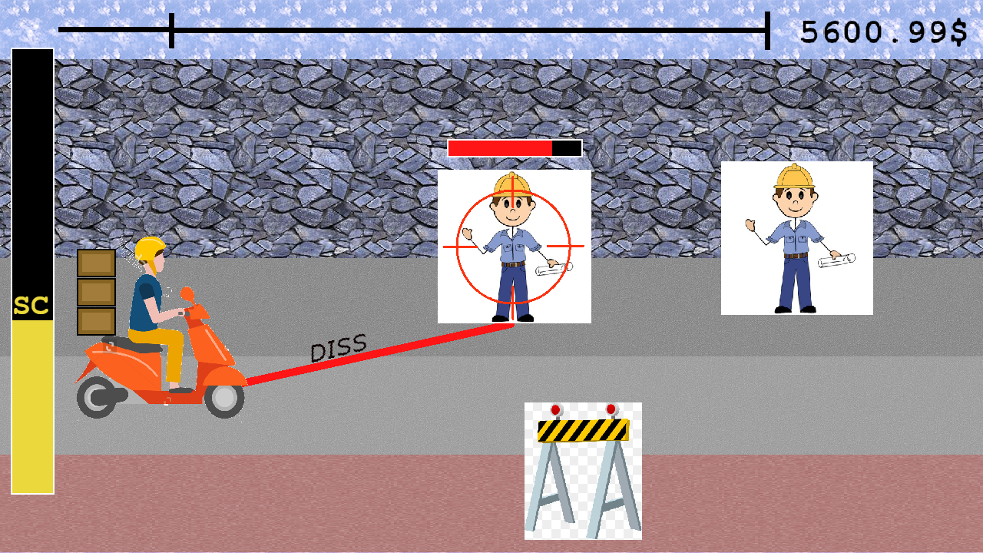
Stage select menu example (stage 1-2 currently selected, stage 1-3 locked until rebel reaches stated SC rank):
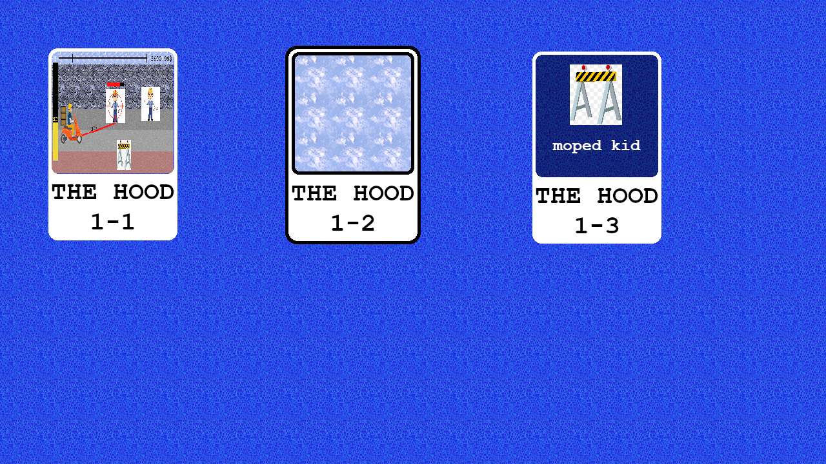

Game Object Nodes/components hierarchy:
- Obstacle
  - static body
  - idle animation
  - crash sound
- Citizen
  - rigid body
  - idle animation
  - getting dissed animation
  - crash animation
  - crash sound
  - dissed sound
- Track
  - tiles
  - flash red animation
  - obstacle flash sound?
- BG
  - parallax master
    - parallax layer 1
      - sprite
    - parallax layer 2
      - sprite
    - parallax laye 3?
      - sprite?
- HUD
  - Track tracker
    - track sprite
    - moped sprite
  - SC progress bar
    - progressbar
    - SC label
  - SC gain label
  - Diss reticule
    - reticule sprite
  - Diss progress
    - progressbar
  - citizen on track icon
    - icon sprite
    - flashing animation
  - diss aiming
    - screen darkener sprite
- Moped
  - camera
  - kinematic body
  - moped sprite
  - drive animations
  - swerve animations
  - crash obstacle animation
  - crash citizen animation
  - dissing animation
  - delivery packages
    - package sprite
    - fly off animation
  - ride engine sound
  - swerve sound
  - crash sound
  - dissing sound
  - gain SC sound
  - diss success sound

Logic notes:
Tracks are numbered – indexed. At any given point moped is on specific track and switches track and current track idx when swerves.
Citizen or obstcle is also on specific track. If moped crashes into obstacle or citizen, there is recovery and its placed back on the first non-dangerous track below this one (above if no safe tracks below)

Dissing only possible after aiming for a diss. When aiming starts hold down button – slows down time around to pick diss target.
Initially reticule appears next to rebel and is guided to required citizen. When citizen selected hold diss button to stop aiming and start dissing. Aiming button can be let go.
If first let go aiming then dissing cancelled (handicap threshold – last aimed target get dissed if hold diss button soon after letting go aiming)

Successfull diss will generate SC multiplier, used when getting SC from driving non-regulation tracks. When rode onto track counter starts. After exit track (crash also counts), a tally is shown of (track SC/s) X (Diss multiplier) X (num of seconds on track) = +SC.

Top bar progress tracks distance from track end for moped – length of all tracks known in advance per track.
During stage money is a static label at the top – money talley performed after stage based on SC and remaining deliveries.

